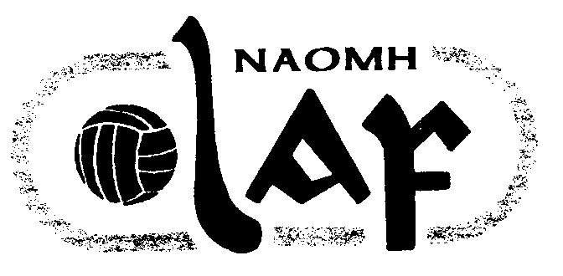
NAOMH OLAF GAA CLUB
Peil (Football)/ Iomaint (Hurling) Fixtures 2004
Week Ending 23rd June 2004

Roinn  (Age) | La  (Date) | Am  (Time) | I gCoinne  (Opposition) | Ionad  (Venue) | Comortas  (Competition) | Naomh Olaf Score | Opposition Score
U9 F | Sat 19th | 10:00 | ClannaGael/Fontenoy | Pairc Ui Bhriain | Group
U10 F | Wed 16th | 6.00 | Cuala A | Thomastown | League
U10 F | Sat 19th | 11.00 | Ballyboden St Enda’s | Santia Maria | League
U12 F | Wed 16th | 7.30 | Cuala B | Pairc Ui Bhriain | League
U12 H | Sat 19th | 12.00 | Visitor * | Pairc Ui Bhriain | Leinster Festival
U13 F | Tues 15th | 7.30 | Ballinteer St John’s | Pairc Ui Bhriain | League
U13 F | Sat 19th | 3.30 | Scoil Ui Chonaill | St Anne’s 22 | League
U13 Camogie | Sat 19th | 2.00 | Ballyboden St Enda’s | Pairc Ui Bhriain | League | Off | Off
U14 F | Sat 19th | 3.30 | Ballinteer St John’s | Pairc Ui Bhriain | League
Adult Div 3H | Thurs 17th | 7.30 | St Vincent’s | Pairc Nh Uinsionn | Championship
Adult Div 6H | Fri 18th | 7.30 | Liffey Gaels | Pairc Ui Bhriain | Championship
Adult Div 2 F | Sat 19th | 7.00 | Whitehall Colmcille | Pairc Ui Bhriain | AIB Cup
Adult Div 5 F | Sun 20th | 11.00 | Portobello | Pairc Ui Bhriain | Conlon Cup
Adult Div 7 F | Sun 20th | 11.00 | Stars of Erin | Pairc Ui Bhriain | Parson Cup
Ladies U14 F | Fri 18th | 7.30 | Clanna Gael Fontenoy | Sean Moore Pk | Shield
Ladies U16 F | Sun 20th | 4.30 | St Peregrine’s | Pairc de Burca | League
Ladies U18 F | Mon 21st | 7.30 | Round Towers ( C ) | Pairc Ui Bhriain | League | Off | Off
LadiesSenior F | Wed 23rd | 7.30 | Parnells | Chanel College | Cup

- Leinster Festival Section 14: Naomh Olaf, Kilmacud Crokes B, Mount Leinster Rangers Carlow, Carnew Emmets Wicklow.
- Programme runs from 12.00 to 4.15.

